**DAILY REPORT**

**Student Name :SINDHU.N**

**Class and Sec : VI B**

**USN :4AL17CS094**

**DATE:22-07-2020**

|  |  |  |  |  |
| --- | --- | --- | --- | --- |
| **Online Test Details** | | | | |
| **Subject** | CGV | | | |
| **Semester** | **VI -B** | | **Duration** | 50Minutes |
| **% of marks**  30 | | ---- | | |

|  |  |  |  |
| --- | --- | --- | --- |
| **Certification Course Details** | | | |
| **Course** | Python for Everybody | | |
| **Certificate Provider** | Coursera | **Duration** | 19hours |

**Snapshots of the daily class acitivities .**

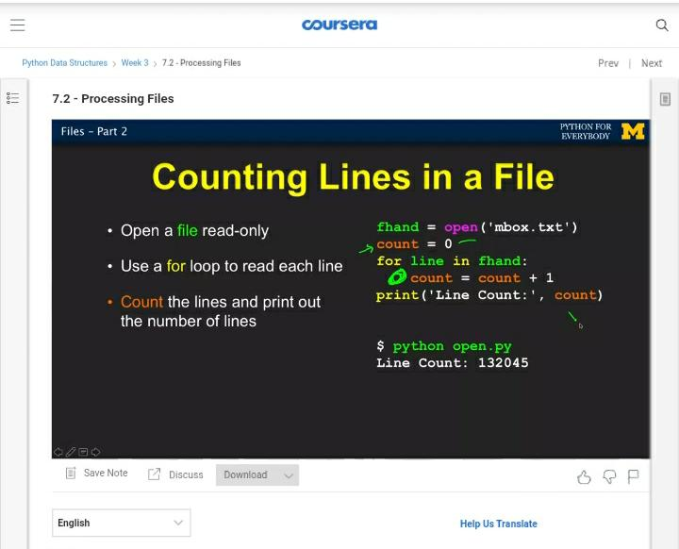

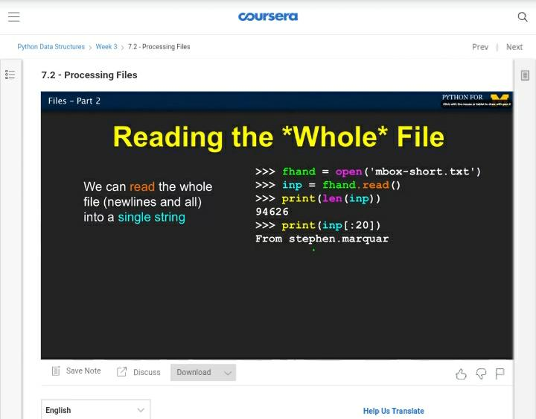

|  |  |
| --- | --- |
| **Coding Challenges** | |
| **Problem Statement: 1.Python Program for Check if count of divisors is even or odd.** | |
| **Status:** Executed | |
| **Uploaded the report both in Github & Slack** | Yes |

**Snapshots of your response to challenge.**

1. ****Python Program for Check if count of divisors is even or odd.****

**import math**

**def countDivisors(n) :**

**count = 0**

**for i in range(1, (int)(math.sqrt(n)) + 2) :**

**if (n % i == 0) :**

**if( n // i == i) :**

**count = count + 1**

**else :**

**count = count + 2**

**if (count % 2 == 0) :**

**print("Even")**

**else :**

**print("Odd")**

**print("The count of divisor: ")**

**countDivisors(10)**

****OUTPUT****

